TYPE: Test

TASK 3: Cells, Tissues and Metabolism Test (78 marks)
Students will complete a number of questions relating to cells, tissues and metabolism. These questions will address specific content as well as analysis of second hand data. This task will be completed in one session under test conditions.

Time for the tasks (1 hour)
- 5 minutes reading time
- 55 minutes working time

What you need to do:

- Follow the instructions provided very carefully to complete the test.
- Draw any results in pencil and answer all questions given.
- It is your responsibility to organise your time effectively.
- There is to be no discussion between you or any of your class mates.
- No sharing of any equipment or answers at all.

Requirements for assessment | Date
- Complete all questions | ___________________

Section | Type of question | Marks Available | Your Mark
1. | Multiple Choice | 23
2. | Short Answer | 45
3. | Extended Response | 10
 | TOTAL | 78 | /78
 |  |  | %

DO NOT TURN THIS PAGE OVER UNTIL YOU ARE TOLD TO

STUDENT NAME: ANSWER KEY

TEACHER: Mrs Cunningham

YEAR: 11
Cells Tissues & Metabolism Test

PART A: Multiple choice questions. 22 marks

Please mark your answers on the answer sheet provided.

1. Energy for the cell’s use is released in the form of

a. heat
b. bADP
c. ATP
d. DNA

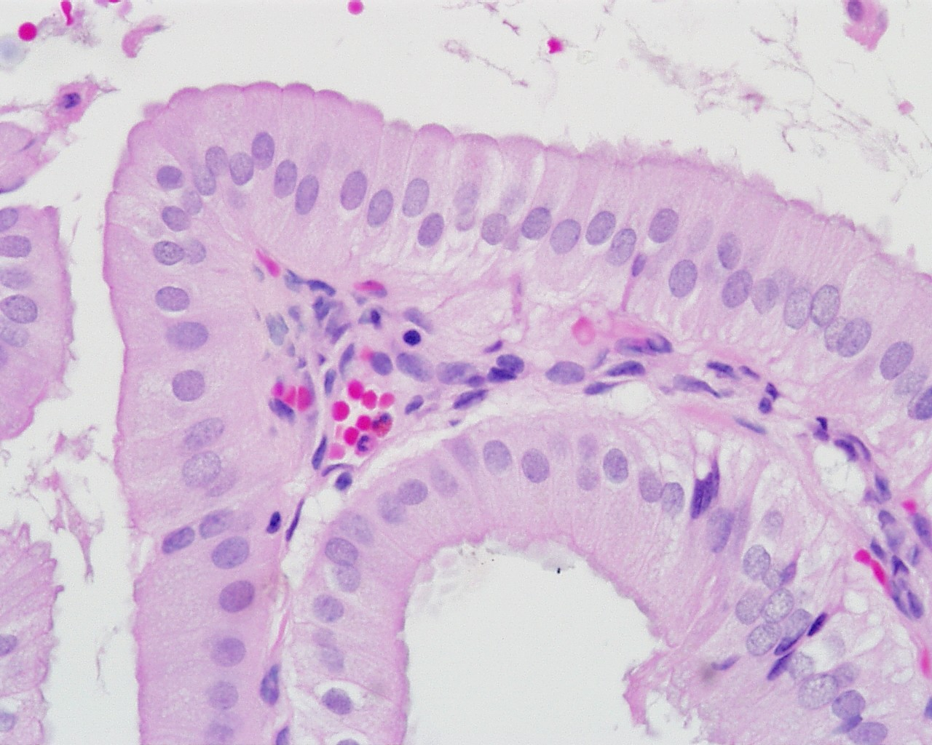
2. The picture below is showing the tissue called;

a. columnar epithelium
b. smooth muscle
c. adipose tissue
d dense connective tissue

3. The process by which a substance spreads from an area of high concentration to an area of low
concentration is known as

a. pinocytosis
b. osmosis
c. active transport
d. diffusion

4. Enzymes are:

a. organic catalysts
b. consumed in chemical reactions
c. needed for all chemical reactions
d. organic reactants

5. All cells obtain energy for their general metabolic activity by the oxidation of glucose. This basic process is known as cellular

a. reproduction
b. respiration
c. photosynthesis
d. metabolism

6. The pictures below are showing the tissues called respectively:

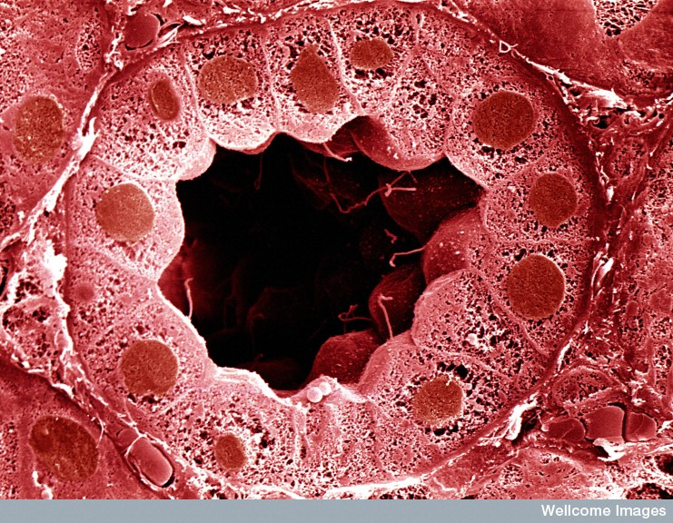
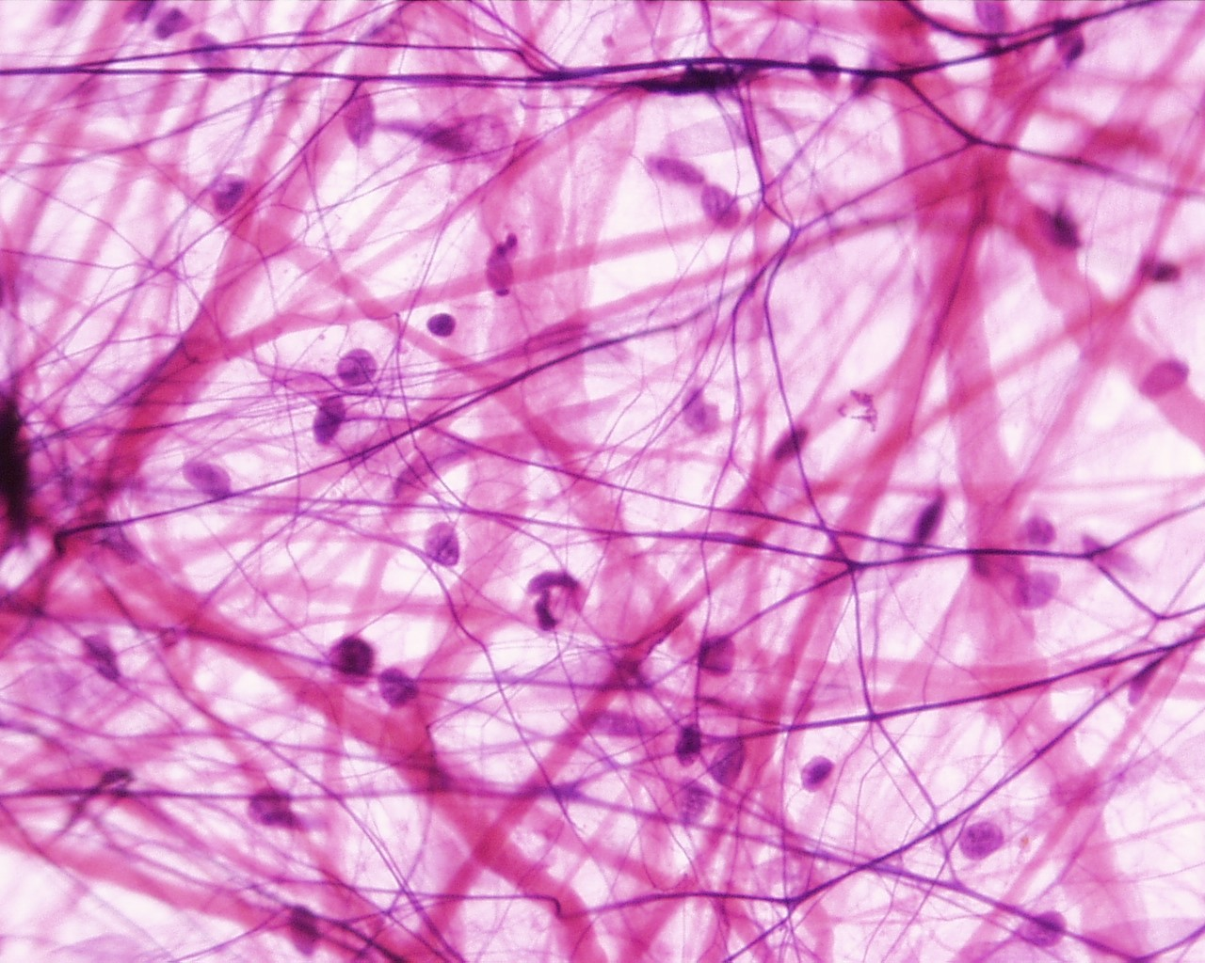

a. bone and hyaline cartilage
b. cuboidal epithelium and loose connective tissue
c. loose connective tissue and cuboidal epithelium
d. bone and smooth muscle

7.

Enzyme Activity

1 2 3 4 5 6 7
pH

The above enzyme is active in the stomach. What is the optimum pH (acidity) for this enzyme?

a. neutral – pH 7
b. acidic – pH 4
c. basic
d. pH 5

8. Active transport occurs when the substances move across membranes :

a. from lower to higher concentrations
b. from higher to lower concentrations
c. by osmosis
d. by simple diffusion

9. The living content of this plant cell has a concentration of ions equivalent to
a. less than 0.6 M salt solution
b. equal to 0.6 M salt solution
c. more than 0.6 M salt solution
d. cannot say due to insufficient data

10. A protein is made up of:

a. simple sugars
b. fatty acids
c glycerol
d. amino acids

11. A student wanted to investigate the relationship between cell size and the rate at which substances enter cells. For this investigation he cut potato into cubes of 3 sizes: cube 1 was 5 mm³, cube 2 was
10 mm³, and cube 3 was 20 mm³. The cubes were covered in iodine for 5 minutes, after which they were removed and cut in half. Which cube had the smallest surface area to volume ratio?

a. Cube 1
b. Cube 2
c. Cube 3
d. None, as iodine is too large to enter the cell.

12. A student set up an experiment with a semipermeable membrane. The membrane was not permeable to sucrose (a sugar). At the beginning of the experiment the same amount of water was added to both sides of the membrane. The student than added sucrose to the left side of the membrane as shown in the following diagram.

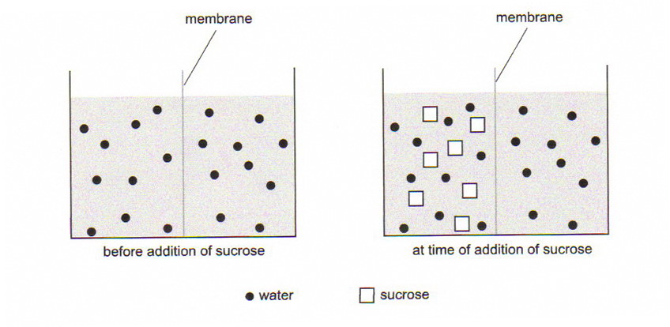

You would expect:

a. the level of water to rise on the left of the membrane
b. the level of water to rise on the right of the membrane
c. the level of water to remain unchanged on both sides of the membrane
d. the concentration of sucrose to increase on the right side of the membrane

13. The organic nutrient with the highest energy value is:

a. sugar
b. starch
c. fat
d. protein

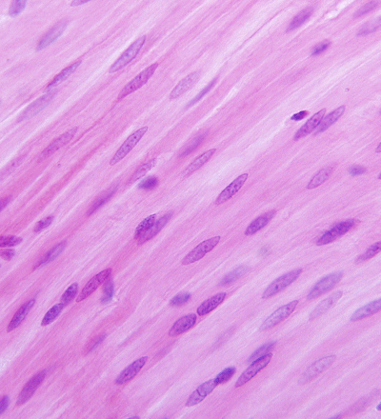
14. The pictures below are showing the tissues called respectively:

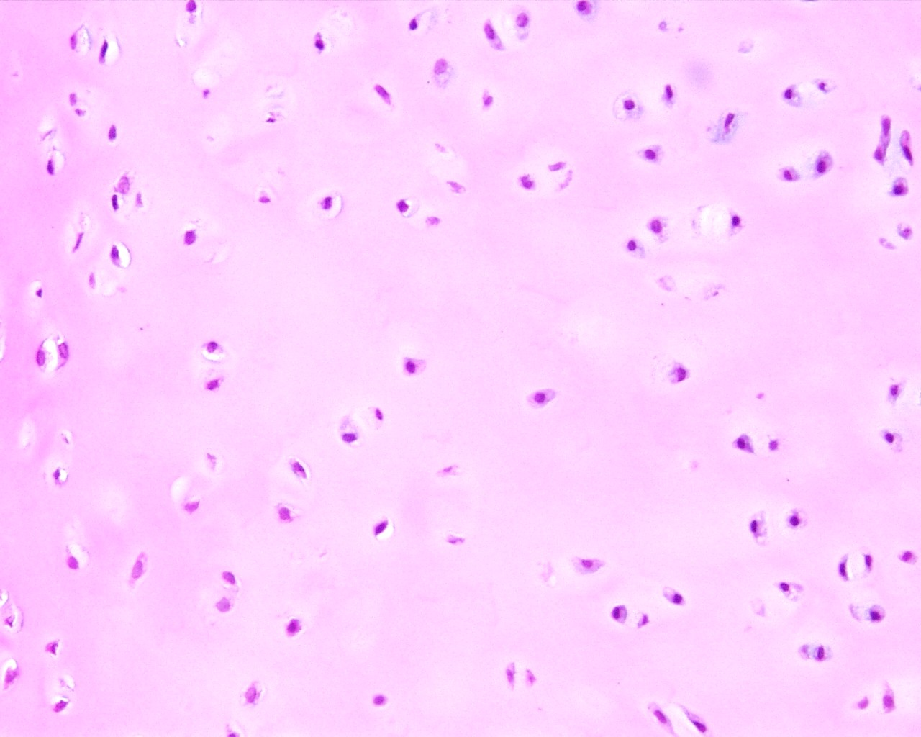

a. striated muscle and bone
b. smooth muscle and hyaline cartilage
c. adipose tissue and smooth muscle
d, hyaline cartilage and smooth muscle

15. Four students were asked to design a first-hand investigation to determine the effect of pH on the activity of an enzyme. Their investigation designs are shown in the tables below.

Key: E=enzyme S=substrate

DESIGN A |  |  |  |  | DESIGN B
TUBE # | CONTENTS | pH | TEMP (^{O}C) |  | TUBE # | CONTENTS | pH | TEMP (^{O}C)
1 | E | 3 | 20 |  | 1 | E + S | 3 | 20
2 | E | 7 | 20 |  | 2 | E + S | 7 | 20
3 | E | 12 | 20 |  | 3 | E + S | 12 | 20
4 | S | 3 | 20 |  | 4 | S | 3 | 20
5 | S | 7 | 20 |  | 5 | S | 7 | 20
6 | S | 12 | 20 |  | 6 | S | 12 | 20

DESIGN C |  |  |  |  | DESIGN D
TUBE # | CONTENTS | pH | TEMP (^{O}C) |  | TUBE # | CONTENTS | pH | TEMP (^{O}C)
1 | E + S | 3 | 10 |  | 1 | E + S | 7 | 10
2 | E + S | 7 | 20 |  | 2 | E + S | 7 | 20
3 | E + S | 12 | 30 |  | 3 | E + S | 7 | 30
4 | S | 3 | 10 |  | 4 | S | 7 | 10
5 | S | 7 | 20 |  | 5 | S | 7 | 20
6 | S | 12 | 30 |  | 6 | S | 7 | 30

Which investigation is the most appropriate?

a. design A
b. design B
c. design C
d. design D

16. In facilitated diffusion

a. transport is quicker than normal diffusion
b. transport is selective
c. transport of one substance is stopped by another
d. all of the above

17. Which of the following statements describes the diagram below correctly?

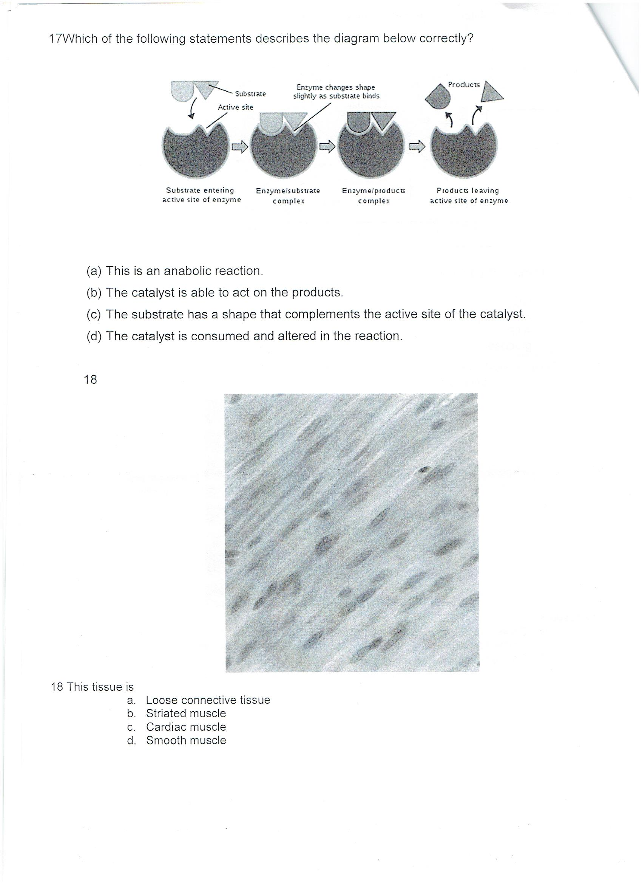

a. This is an anabolic reaction.
b. The catalyst is able to act on the products.
c. The substrate has a shape that complements the active site of the catalyst.
d. The catalyst is consumed and altered in the reaction.

18 Which of the following statements best defines osmosis?

a. The movement of water along a concentration gradient, without the expenditure of ATP.
b. The movement of water against a concentration gradient, without the expenditure of ATP.
c. The movement of water against a concentration gradient, through a semi-permeable membrane.
d. The movement of water along a concentration gradient, through a semi-permeable membrane, requiring the expenditure of ATP.

19. The concentration of lactic acid in a muscle is greater after exercise than it is before exercise. This is
because there is;

a. insufficient oxygen in the muscle during exercise.
b. an excess of carbon dioxide in the muscle.
c. insufficient glucose in the muscle.
d. a high rate of aerobic respiration.

20. ATP is essential to every living cell, because it;

a. controls metabolic rate.
b. stores energy released during the breakdown of ADP.
c. stores energy in a form that is readily available.
d. reacts with glucose to form energy.

21. Which of the following does not match the nutrient with its sub-units?

a. Vitamins – made up of minerals
b. Proteins – made up of amino acids
c. Carbohydrates – made up of monosaccharides
d. Lipids – made up of fatty acids and glycerol

22. The pictures below are showing the tissues called respectively:

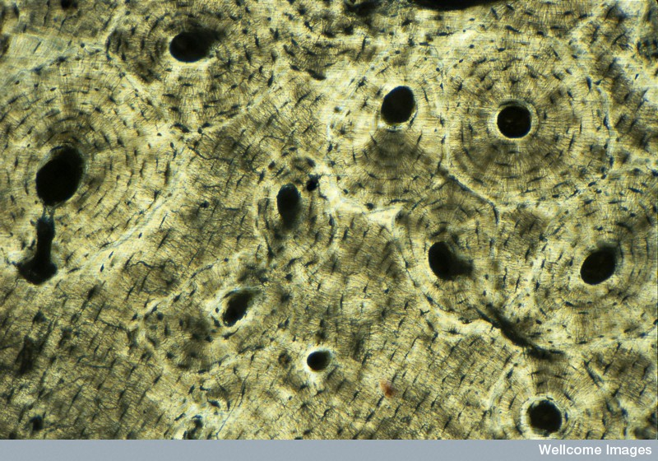
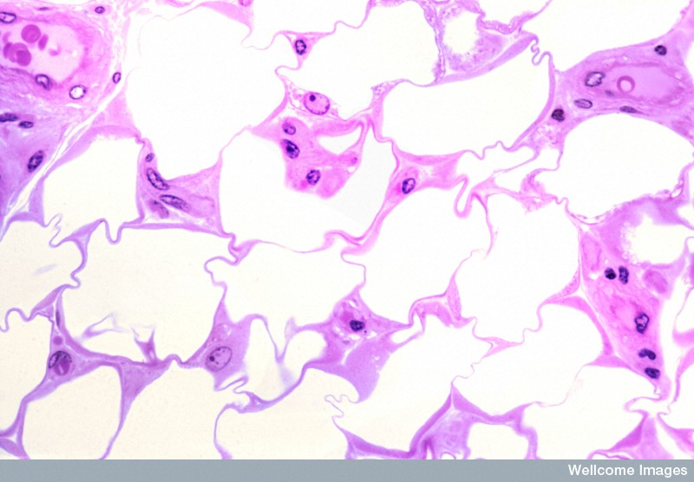

a. Bone and loose connective tissue
b. adipose tissue and bone
c bone and nervous tissue
d. smooth muscle and bone

23. Which list below correctly has the hierarchy of biological organization?

a. molecules, cells, tissues, organs, systems
b. molecules, cells, tissues, systems, organs
c. cells, organs, tissues, systems,
d. tissues, cells, systems, organs

END OF MULTIPLE CHOICE QUESTION SECTION

PART B: Short Answer questions. (45 marks)

Please write your answers in the spaces provided on this sheet.

1. a) Write the balanced chemical equation for cellular respiration: all or none

_______ C₆H₁₂O₆ + 6 O₂ 6 CO₂ + 6 H₂O + Energy
[1 marks]

b) Draw and label an ATP molecule. Use your diagram to explain where energy is released from.
Adenosine
-------P-------P P

The bond between the second and third phosphate is a high energy bond, and when energy is required the bond is broken releasing the energy.

[2 marks
c) List three reasons cells require energy:

i) __building complex molecules; cell division and growth; movement of cell organelles; movement of whole cell; maintaining cell organisation, active transport; transmission of nerve impulses

ii) ____________________three of the above

iii) ________________________________________________________
[3 marks]

2. The following graph shows the results of an experiment involving the breakdown of starch by an enzyme.

Effect of temperature on breakdown of starch by an enzyme
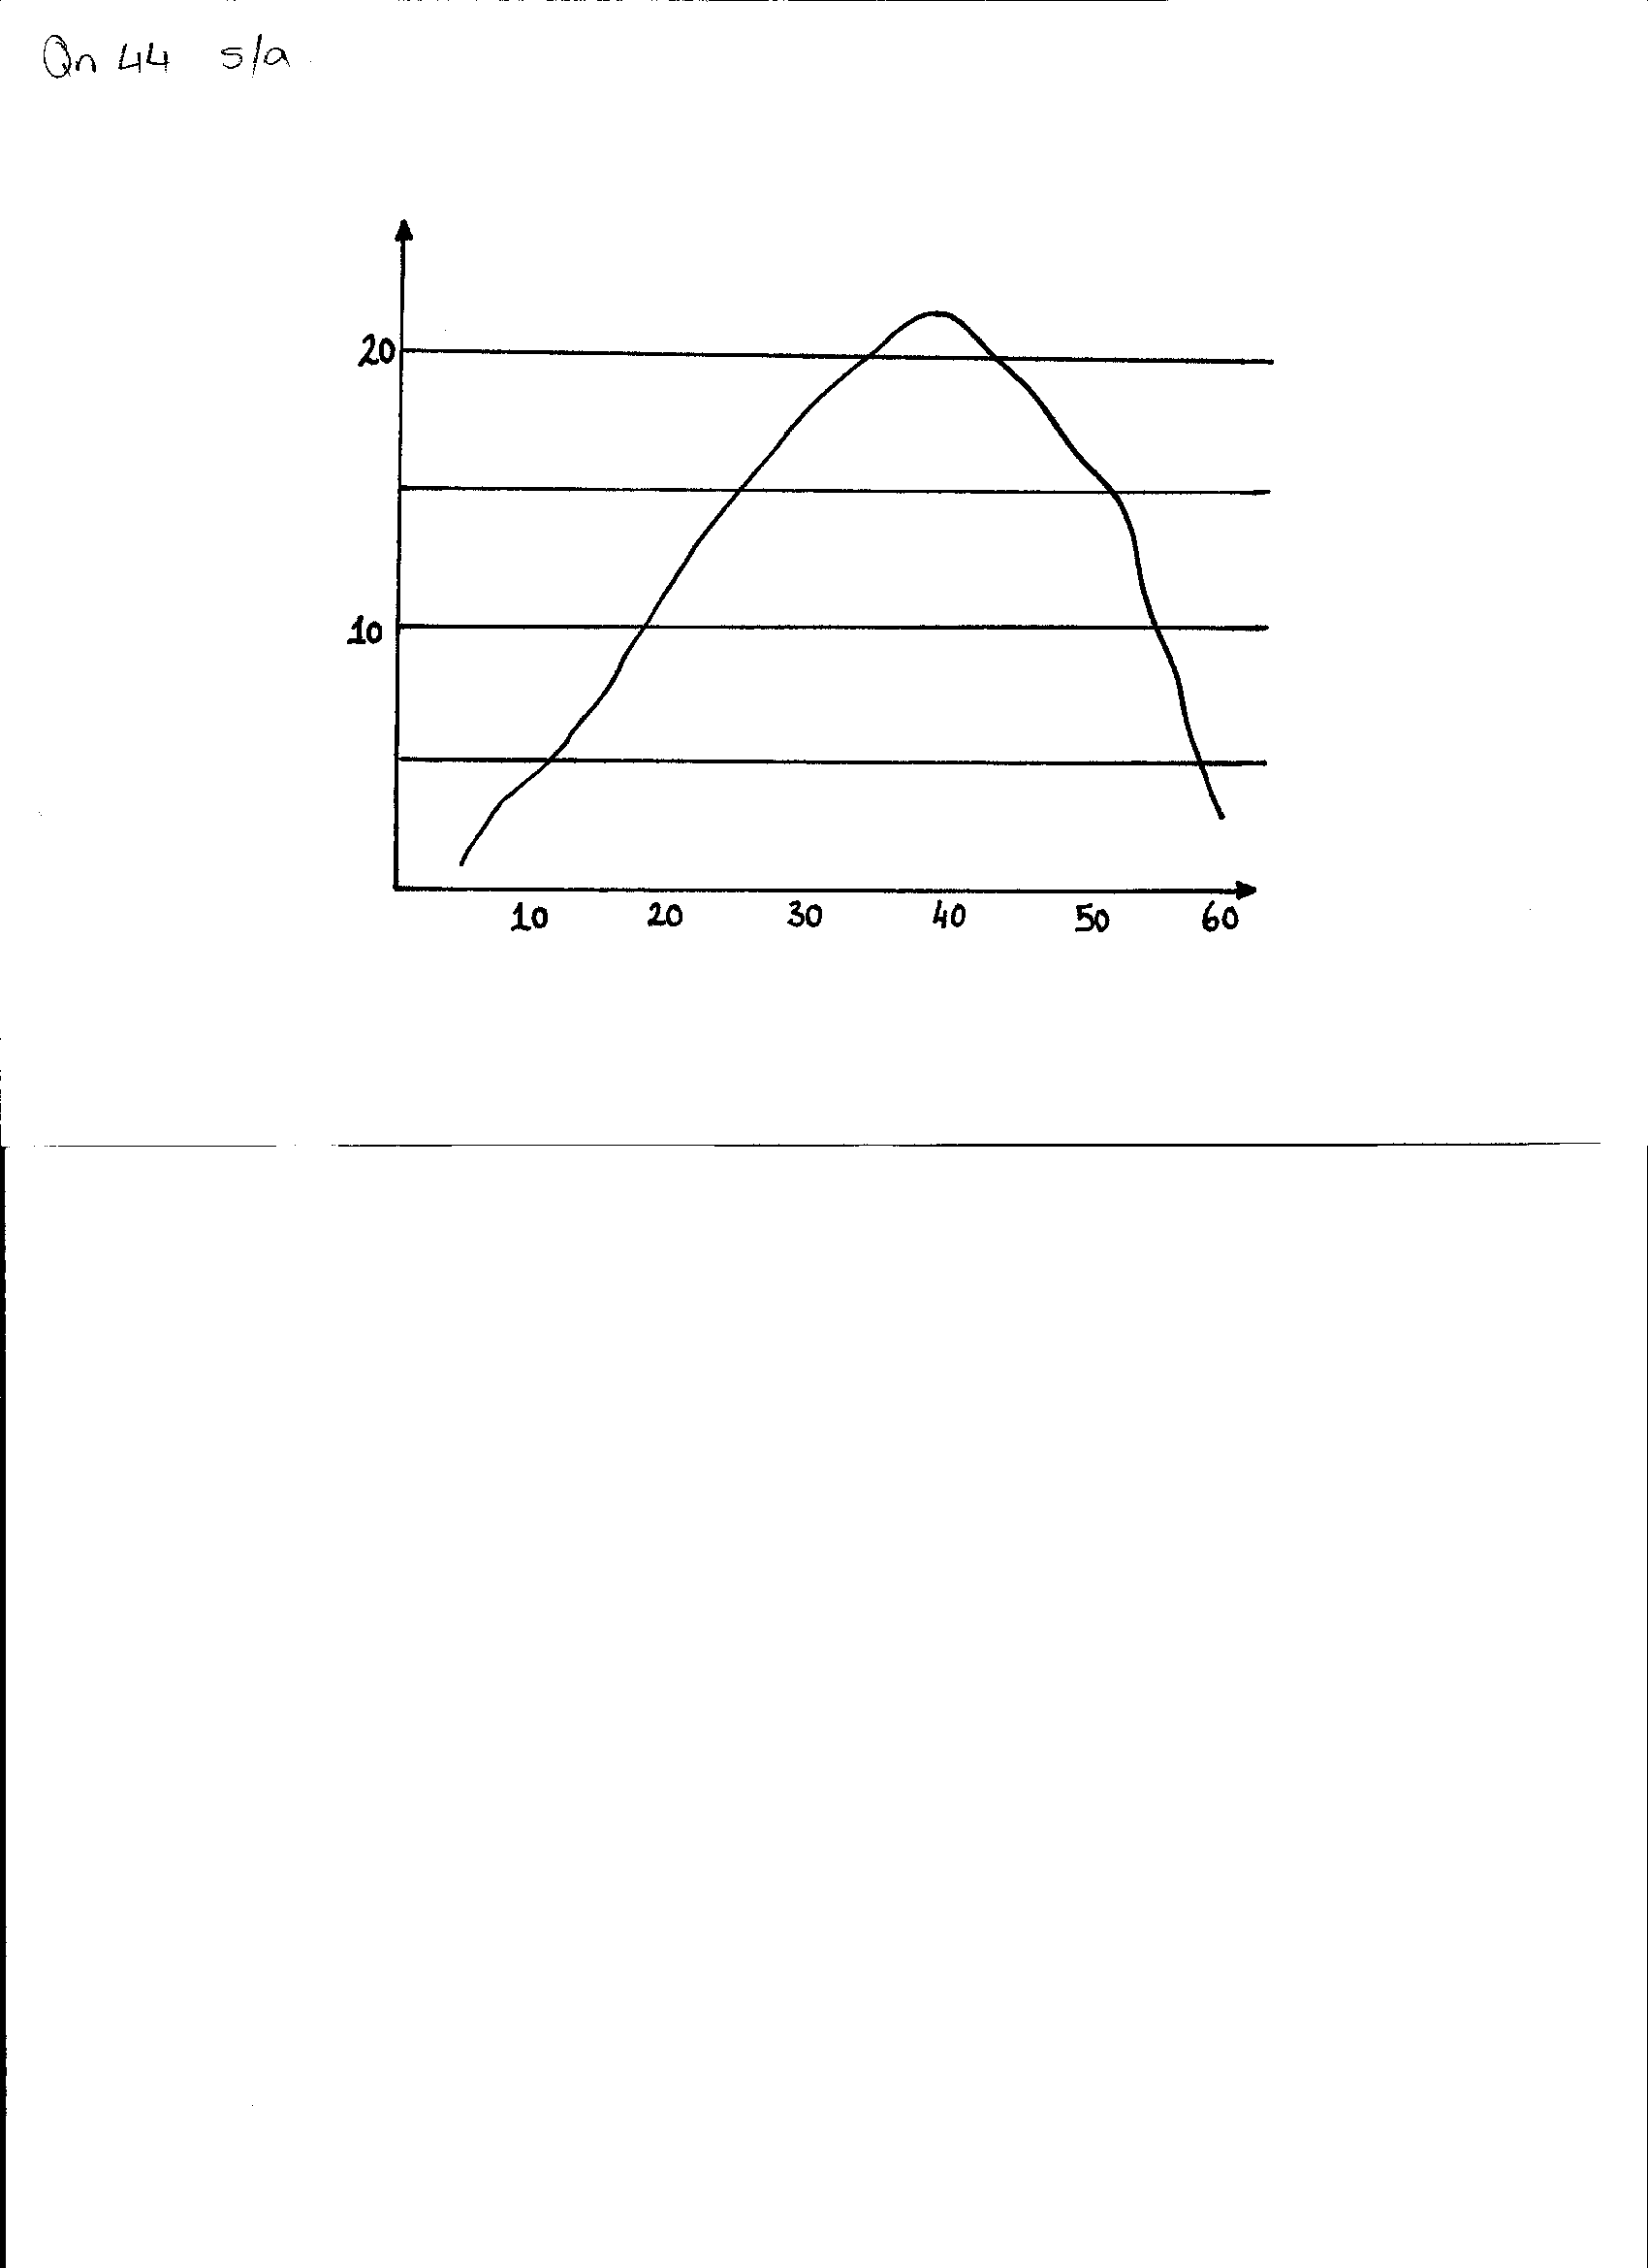

Enzyme activity in mg of starch broken

Temperature in ^{O}C

a. What is the optimum (best) temperature for the activity of this enzyme? (1 mark)
40ºC +/- 1

b. Why does the rate of reaction drop rapidly at body temperatures above 45^{O}C? (1mark)

At 45ºC the enzyme molecules would be breaking down, or de-naturing

c. What is the end product from the digestion of starch? (1 mark)
glucose

d. Name the substrate of the enzyme lipase. (1 mark)
Lipids
______________________________________________________________________

e. State ONE factor, other than temperature, which affects the activity of an enzyme. (1 mark)

pH; concentration; substrate concentration; removal of products; presence of co-factors

3. Explain the following processes, where they occur in the cell and the amount of energy each
process yields.

a. Aerobic respiration (3 marks)
- with oxygen 1
- occurs in cytosol/cytoplasm, and mitochondria 1
- produces 2 + 36 = 38 ATP 1

b. Anaerobic respiration (3 marks)
without oxygen 1
- Occurs in cytosol/cytoplasm 1
- Produces 2 ATP 1

4. Explain the differences in function between the three types of muscle tissue.

- Skeletal muscle – attaches to bone, allows movement – voluntary muscle
- Smooth muscle – in glands, blood vessels ,organs;,walls of stomach; intestines – involuntary
control
- cardiac muscle – in the heart continually contracting /pumping blood around the body involuntary control
1 mark for name, one for function [6 marks]

5. A student observed changes in a red blood cell which was placed in distilled water. Draw in the boxes below, sketches of what she would have seen at those times.

Normal cell
Cell after 10mins
Cell after 30 mins
Or the cell has bursts [1 mark]

a. What is the name for this process? [1 mark]
osmosis
________________________________________________________

b. Explain your drawings …Why does the cell change? (4 marks)

concentration of water is greater outside the cell than inside /1

water moves through the differentially permeable membrane, / 1

and into the cell to equalize the concentration / 1

water continues to move into the cell until concentrations are equal or the cell bursts /1

_________________________________________________________________________________________________________________________________________________________________

____________________________________________________________________

6. What compounds are synthesised in the human body from the following sub-units: (3 marks)

- Glucose glycogen
- Amino acids proteins
- Fatty acids & glycerol Lipids

7. For each of the following processes, state whether the chemical reactions are anabolic or catabolic
reactions. (3 marks)

- Protein synthesis _________anabolic
- Aerobic respiration _________catabolic
- Anaerobic respiration _________catabolic

8. a. Label the structures in the diagram below, by writing the name next to the matching letter in the table. ( 8 marks)
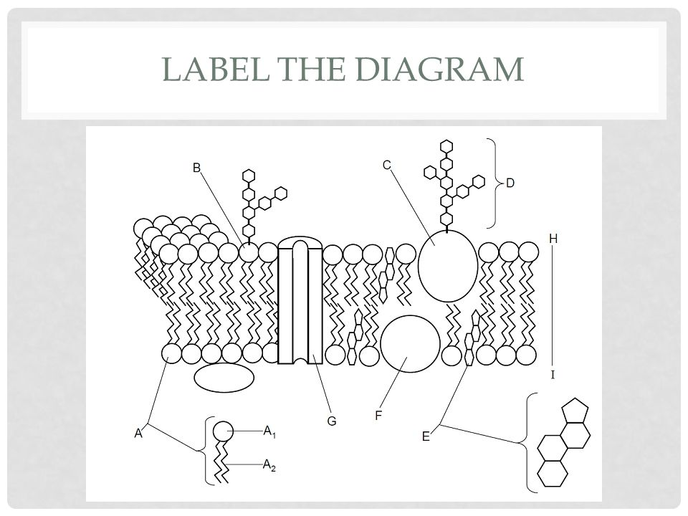
STRUCTURE | NAME 1 mark per structure
A₁ | Hydrophilic heads
A₂ | Hydrophobic tails
C | Protein
D | carbohydrate
E | cholesterol
F | protein
G | Protein channel
H - I | Phospholipid bi-layer / cell membrane

b. What different properties do A₁ and A₂ have? (2 marks)
A1 is hydrophilic / B is hydrophobic

c. What is the function of structure G? (1 mark)

To provide a channel for substances such as ions, water and small molecules to pass through the cell membrane

9. Draw diagrams to show the process of phagocytosis. (2 marks)

Must show cell and separate membrane, solid material

Show membrane partially wrapped around solid,

Then solid in vesicle.inside the cell.

End of Short Answer Questions

PART C: Extended Answer questions. (10 marks)

Please write your answers in the spaces provided on this sheet.

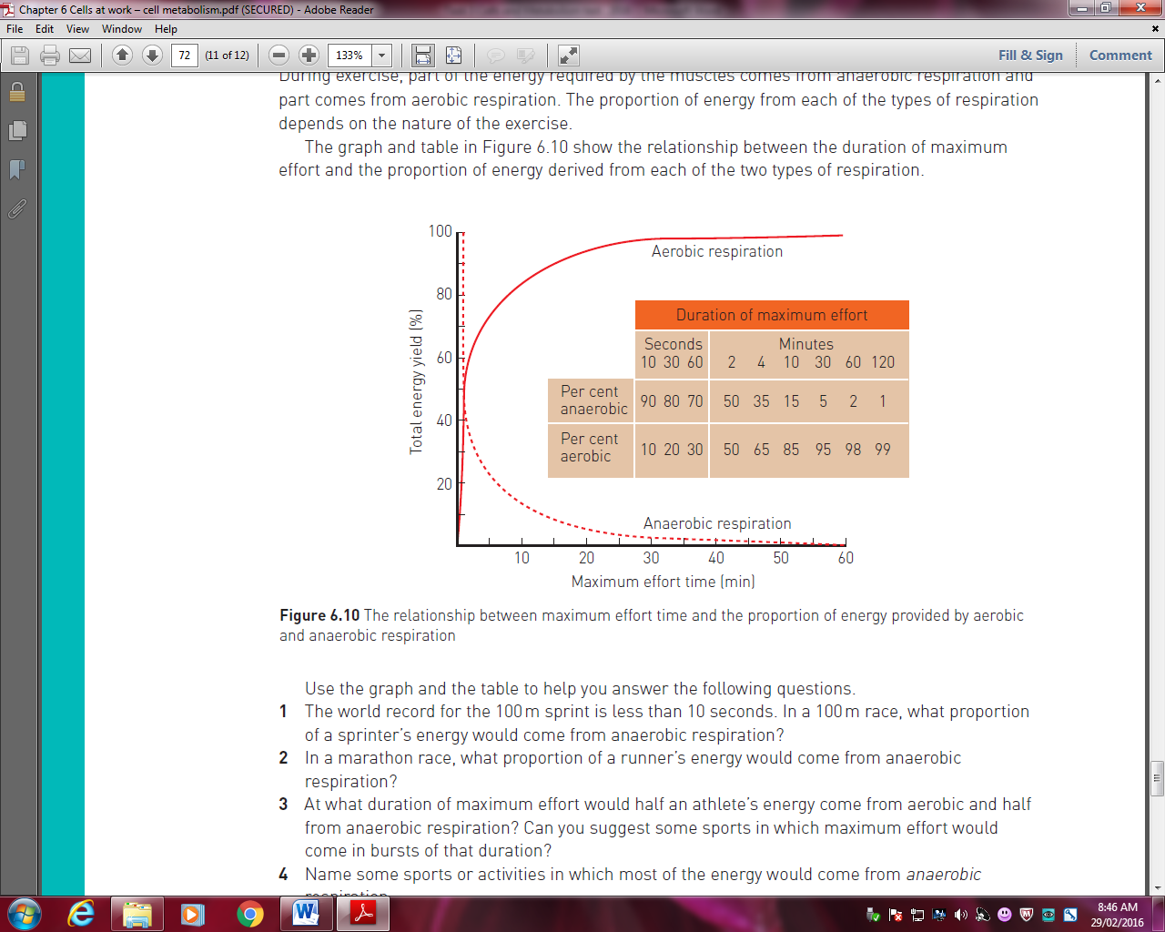
8. During exercise, part of the energy required by the muscles comes from anaerobic respiration and part comes from aerobic respiration. The proportion of energy from each of the types of respiration depends on the nature of the exercise. The graph and table below show this relationship.

Using the information above and your knowledge of respiration, explain why some observers noted that a sprinter who had just run 400m in 50 seconds was breathing much more heavily than a runner who had just completed a marathon in 2.5 hours.
_______________________________________________________________________________________________________________________________________________________________________________________________________________________________________________________________________Answer: A sprinter would gain energy from anaerobic respiration. /1
Lactic acid / 1 that is produced during anaerobic respiration /1must be converted to glucose /1 and then to glycogen in the liver /1
This process requires oxygen / 1 so the body incurs an ‘oxygen debt’ / 1 when cells are anaerobically respiring.
Once the exercise ceases, breathing is heavy / 1 so that the oxygen debt can be repaid/ 1.
The marathon runner does not need recovery oxygen / 1 because most of the energy would be produced via aerobic respiration._/ 1

Up to 10 marks
________________________________________________________________________________________________________________________________________________________________________________________________________________________________________________________________________________________________________________________________________ END OF TEST

